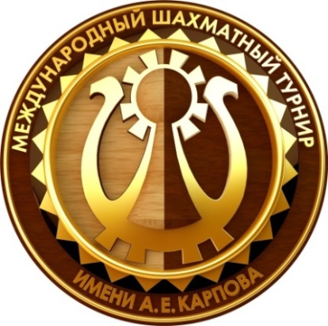

The 17 ^{th} Anatoly Karpov,s Chess Tournament
23.07. – 01.08. 2016 Poykovsky (Russia)

Round 1. /18.00/
23 July /saturday/
Bologan, Victor |  |  | - |  |  |  | Motylev, Alexander
Korobov, Anton |  |  | - |  |  |  | Wojtaszek, Radoslaw
Matlakov, Maxim |  |  | - |  |  |  | Kovalenko, Igor
Smirin, Ilia |  |  | - |  |  |  | Jakovenko, Dmitry
Sutovsky, Emil |  |  | - |  |  |  | Andreikin, Dmitry
Round 2. /15.00/
24 July /sunday/

Bologan, Victor |  |  | - |  |  |  | Korobov, Anton
Motylev, Alexander |  |  | - |  |  |  | Andreikin, Dmitry
Jakovenko, Dmitry |  |  | - |  |  |  | Sutovsky, Emil
Kovalenko, Igor |  |  | - |  |  |  | Smirin, Ilia
Wojtaszek, Radoslaw |  |  | - |  |  |  | Matlakov, Maxim
Round 3. /15.00/
25 July /monday/
Matlakov, Maxim |  |  | - |  |  |  | Bologan, Victor
Korobov, Anton |  |  | - |  |  |  | Motylev, Alexander
Smirin, Ilia |  |  | - |  |  |  | Wojtaszek, Radoslaw
Sutovsky, Emil |  |  | - |  |  |  | Kovalenko, Igor
Andreikin, Dmitry |  |  | - |  |  |  | Jakovenko, Dmitry
Round 4. /15.00/
26 July /tuesday/
Bologan, Victor |  |  | - |  |  |  | Smirin, Ilia
Korobov, Anton |  |  | - |  |  |  | Matlakov, Maxim
Motylev, Alexander |  |  | - |  |  |  | Jakovenko, Dmitry
Kovalenko, Igor |  |  | - |  |  |  | Andreikin, Dmitry
Wojtaszek, Radoslaw |  |  | - |  |  |  | Sutovsky, Emil
 |  |  | DEY OFF
27 July /wednesday/
Round 5. /15.00/
28 July /Thursday/
Sutovsky, Emil |  |  | - |  |  |  |  | Bologan, Victor
Smirin, Ilia |  |  | - |  |  |  |  | Korobov, Anton
Matlakov, Maxim |  |  | - |  |  |  |  | Motylev, Alexander
Andreikin, Dmitry |  |  | - |  |  |  |  | Wojtaszek, Radoslaw
Jakovenko, Dmitry |  |  | - |  |  |  |  | Kovalenko, Igor
 |  |  | Round 6. /15.00/
 |  |  | 29 July /friday/
Bologan, Victor |  |  | - |  |  |  |  | Andreikin, Dmitry
Korobov, Anton |  |  | - |  |  |  |  | Sutovsky, Emil
Matlakov, Maxim |  |  | - |  |  |  |  | Smirin, Ilia
Motylev, Alexander |  |  | - |  |  |  |  | Kovalenko, Igor
Wojtaszek, Radoslaw |  |  | - |  |  |  |  | Jakovenko, Dmitry
Round 7. /15.00/
30 July /saturday/
Jakovenko, Dmitry |  |  | - |  |  |  |  | Bologan, Victor
Andreikin, Dmitry |  |  | - |  |  |  |  | Korobov, Anton
Sutovsky, Emil |  |  | - |  |  |  |  | Matlakov, Maxim
Smirin, Ilia |  |  | - |  |  |  |  | Motylev, Alexander
Kovalenko, Igor |  |  | - |  |  |  |  | Wojtaszek, Radoslaw
Round 8. /15.00/
31 July /sunday/
Bologan, Victor |  |  | - |  |  |  |  | Kovalenko, Igor
Korobov, Anton |  |  | - |  |  |  |  | Jakovenko, Dmitry
Matlakov, Maxim |  |  | - |  |  |  |  | Andreikin, Dmitry
Smirin, Ilia |  |  | - |  |  |  |  | Sutovsky, Emil
Motylev, Alexander |  |  | - |  |  |  |  | Wojtaszek, Radoslaw
Round 9. /13.00/
01 August /monday/

 |  | Wojtaszek, Radoslaw |  |  | - | Bologan, Victor
 |  | Kovalenko, Igor |  |  | - | Korobov, Anton
 |  | Jakovenko, Dmitry |  |  | - | Matlakov, Maxim
 |  | Andreikin, Dmitry |  |  | - | Smirin, Ilia
 |  | Sutovsky, Emil |  |  | - | Motylev, Alexander

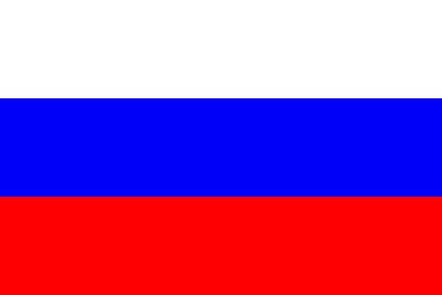
Time limit: 100min/40 moves followed by 50 min. ALL+30 sec/move

Chief Arbiter: ________________ M A Lobanov Yury RUS /Sochi/

