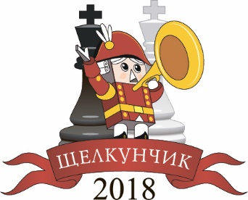
International team tournament
Nutcracker 2018 (Standard)
Round I  17 December,  Games start at 15.00 MSK  - Gelfand, Boris – Paravyan, David  - Najer, Evgeniy – Sarana, Alexey  - Esipenko, Andrey – Leko, Peter  - Lomasov, Semyon – Short, Nigel D | Round II  18 December,  Games start at 15.00 MSK  - Gelfand, Boris – Esipenko, Andrey  - Najer, Evgeniy – Lomasov, Semyon  - Paravyan, David – Leko, Peter  - Sarana, Alexey – Short, Nigel D
Round III  19 December,  Games start at 15.00 MSK  - Sarana, Alexey - Gelfand, Boris  - Esipenko, Andrey – Najer, Evgeniy  - Leko, Peter – Lomasov, Semyon  - Short, Nigel D – Paravyan, David | Round IV  20 December,  Games start at 15.00 MSK  - Lomasov, Semyon – Gelfand, Boris  - Paravyan, David – Najer, Evgeniy  - Leko, Peter – Sarana, Alexey  - Short, Nigel D – Esipenko, Andrey

Chief Arbiter Alexander Tkachev, IA (RUS)

